**HORMISDALLEN SCHOOL - KYEBANDO**

**PRE- PLE SET 4 EXAMINATIONS, 2023**

**PRIMARY SEVEN SCIENCE**

**Duration: 2 Hours 15 Minutes**

**NAME: ______________________________________________ STREAM: _________**

INDEX NO.

EMIS NO.

**SECTION A**

1. Name any one resource obtained from animals.

………………………………………………………………………………………………….

1. How is the behaviour of barking helpful to dogs?

……………………………………………………………………………….……………….

1. State any one way a person can avoid bad smell from the body.

……………………………………………………………………………….……………….

1. In which way is friction useful to a P.7 pupil?

……………………………………………………………………………….……………….

1. Which human body organ is responsible for memorizing and thinking?

……………………………………………………………………………….……………….

Use the diagram of one of the tools used in cleaning our teeth to answer question 6.

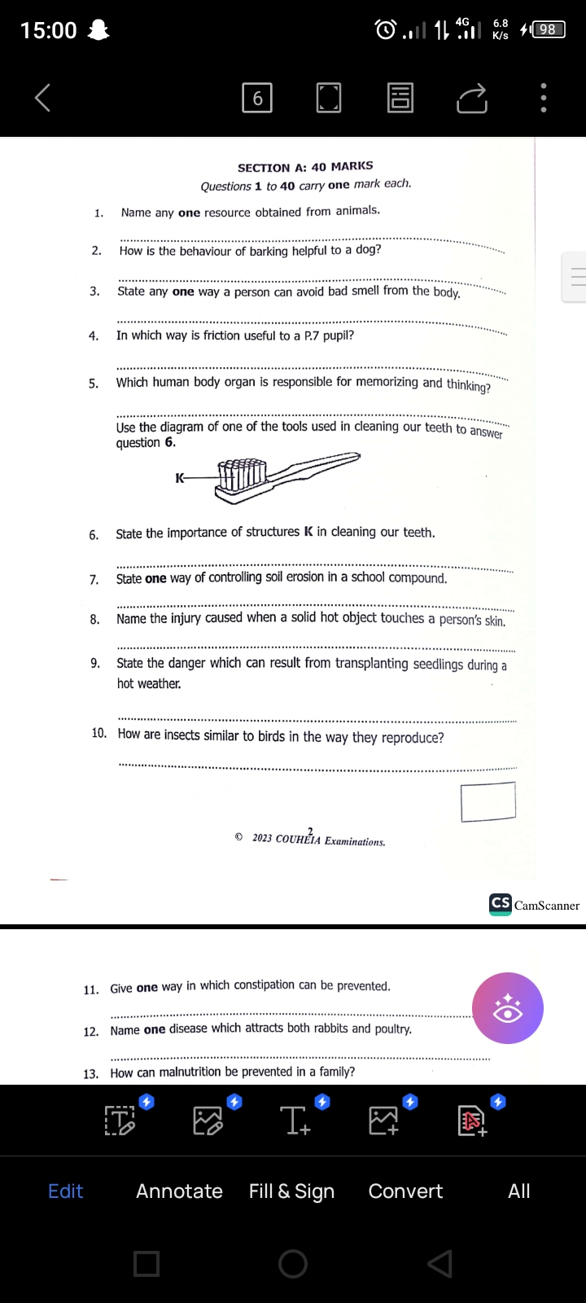

1. State the importance of structures marked K in cleaning our teeth.

………………………………………………………………………………………………….

1. State one way of controlling soil erosion in a school compound.

……………………………………………………………………………….……………….

1. Name the injury caused when a solid hot object touches a person’s skin.

……………………………………………………………………………….……………….

1. State the danger which can result from transplanting seedlings during a hot weather.

……………………………………………………………………………….……………….

1. How are insects similar to birds in the way they reproduce?

……………………………………………………………………………….……………….

1. Give one way in which constipation can be prevented.

……………………………………………………………………………….……………….

1. Name one disease which attacks both rabbits and poultry.

……………………………………………………………………………….……………….

1. How can malnutrition be prevented in a family?

……………………………………………………………………………….……………….

1. State the use of the weather instrument in the diagram below.

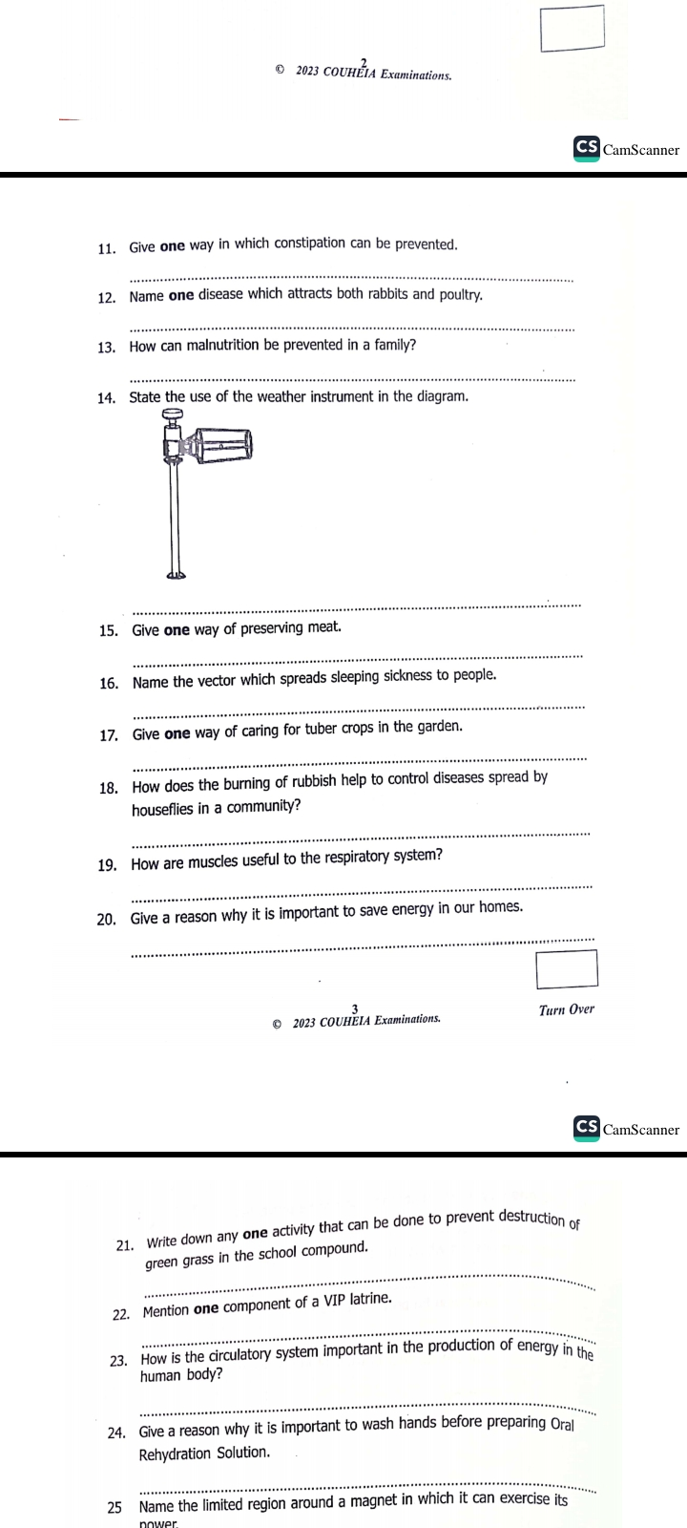………………………………………….……………….

1. Give one way of preserving meat.

……………………………………………………………………………….……………….

1. Name the vector which spreads sleeping sickness to people.

……………………………………………………………………………….……………….

1. Give one way of caring for tuber Crops in the garden.

………………………………………………………………………………………………..

1. How does burning of rubbish help to control diseases spread by houseflies in a community?

…………………………………………………………………………………………….….

1. How are muscles useful to the respiratory system?

…………………………………………………………………………………………….….

1. Give a reason why it is important to save energy in our homes.

…………………………………………………………………………………………….….

1. Write down any one activity that can be done to prevent destruction of green grass in the school compound.

……………………………………………………………………………………….…….....

1. Mention one component of a VIP latrine.

……………………………………………………………………………………….……….

1. How is the circulatory system important in the production of energy in the human body?

………………………………………………………………………………………….…….

1. Give a reason why it is important to wash hands before preparing Oral Rehydration Solution.

………………………………………………………………………………………………….

1. Name the limited region around a magnet in which it can exercise its power.

………………………………………………………………………………….…………….

1. State one way in which animals depend on other animals.

…………………………………………………………………………………….………….

1. How can hookworm infestation be prevented among people in a community?

……………………………………………………………………………….……………….

1. To which group of flowering plants do beans belong?

……………………………………………………………………………….……………….

1. Name the childhood immunisable disease which shows the following signs.

**red eyes, sore mouth, runny nose, cough and rash all over the body**

…………………………………………………………………………………….………….

1. State one way in which egg eating and cannibalism can be controlled in poultry,

…………………………………………………………………………………………….….

1. How does rainfall support plant growth?

………………………………………………………………………………………….…….

1. Give a reason why PHC services should be provided free of charge in the community.

…………………………………………………………………………………………….….

1. In the space provided below, draw a diagram to show the shape of a dairy cow.

|  |
| --- |
|  |

1. Mention one type of smoking.

………………………………………………………………………………………………..

1. State one way in which diseases caused by fungi are spread among people.

…………………………………………………………………………………………….….

The diagram below is of a thermos cup. Study and use it to answer question 36.

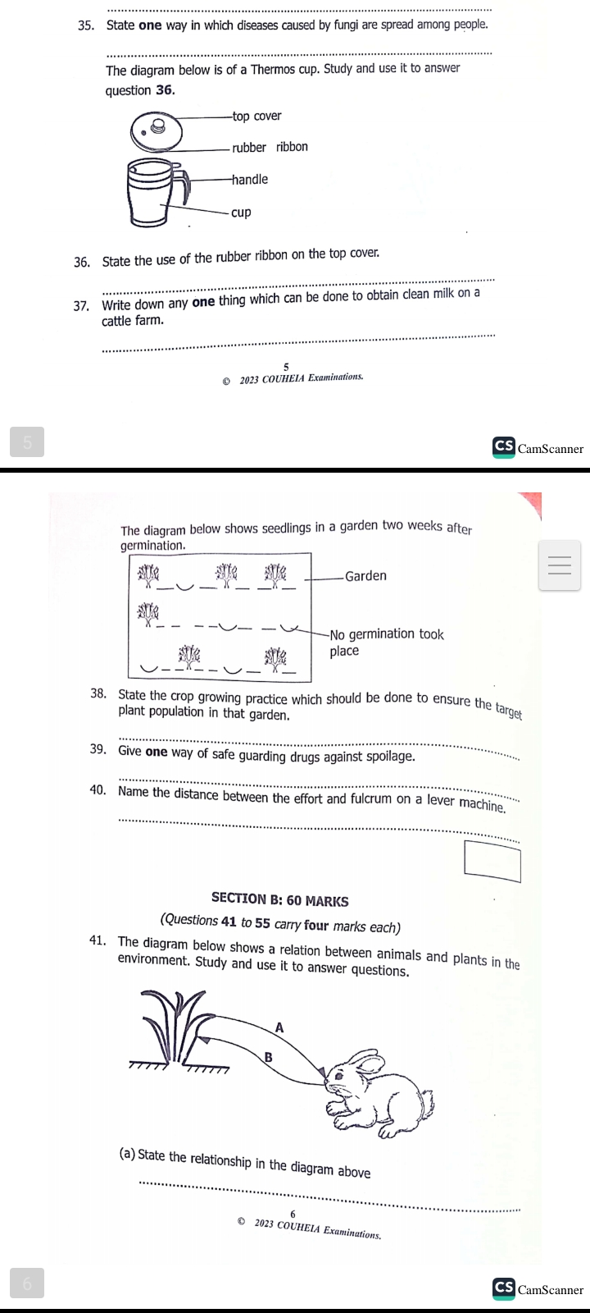

1. State the use of rubber ribbon on the top cover.

………………………………………………………………………………………….…….

1. Write down any one thing which can be done to obtain clean milk on a cattle farm.

………………………………………………………………………………………………..

The diagram below shows seedlings in a garden two weeks after germination.



1. State the crop growing practice which should be done to ensure the target plant population in that garden.

…………………………………………….………………………………………………….

1. Give one way of safe guarding drugs against spoilage.

……………………………………….……………………………………………………….

1. Name the distance between the effort and fulcrum on a lever machine.

…………………………………….………………………………………………………….

**SECTION B**

1. The diagram below shows a relation between animals and plants in the environment. Study and use it to answer questions.



1. State the relationship in the diagram above.

………………………………………………………………………………………….

b) Name the gases represented by letters A and B

i) A………………………………….……………………………………………………….

ii) B………………………………………………………………………………………….

c) State any one way of caring for plants in the environment.

……………………………………….……………………………………………………….

1. a) Give the meaning of the following.

i) drug abuse………………………………………………………………………………..

……………………………………………….……………………………………………….

ii) drug dependence…………………………………………………………………………

…………………………… ……………….…………………………………………………

b) How do frogs differ from toads in the way they breathe?

……………………………………….……………………………………………………….

c) State the importance of jelly which covers the eggs of a frog.

……………….……………….……………….……………….……………….………………

1. a) Apart from amphibians, name two other groups of cold blooded vertebrates.

i)……………………………………………….……………………………………………….

ii)…………………………… ……………….…………………………………………………

b) How do frogs differ from toads in the way they breathe?

……………………………………….……………………………………………………….

c) State the importance of jelly which covers the eggs of a frog.

……………….……………….……………….……………….……………….………………

1. a) What is refraction?

……………………………………………….……………………………………………….

b) What causes the change in speed of light as it passes through different media?

…………………………… ……………….…………………………………………………

c) State one danger caused due to refraction in swimming pool.

………………………… ……………….…………………………………………………

d) How can total internal reflection be prevented in a pin-hole camera?

………………………………………………………………………………………………..

1. a) Name the equipment used for harvesting each of the following resources.

i) Rain water………………………….……………………………………………………….

ii) Heat and light from the sun……………………………………………………………..

b) State one use of energy got from the sun.

…...……………………………… ……………….…………………………………………....

c) How does the use of energy from the sun help to conserve the environment?

………………………………………………….…………………………………………….

d) Show the river widely used for irrigation using letter S on the map above.

………………………………………………….………………………………………….....

1. a) Name the animal fibre which is obtained from goats.

…………………………………………………………………….………………………….

b) Apart from the fibre named in (a) above, give two other products got from goats.

i)…………………………………………………… ……………….………………………

ii)…………………………………………………… ……………….……………………..

c) Mention any one system of grazing goats.

………………………………………………………………………………………………..

1. a) State the method of propagation used with the following crops.
2. Maize……………………………………………………………………………………….
3. Irish potatoes…………………………………………………………………………..

b) Use the diagram below to answer questions that follow.

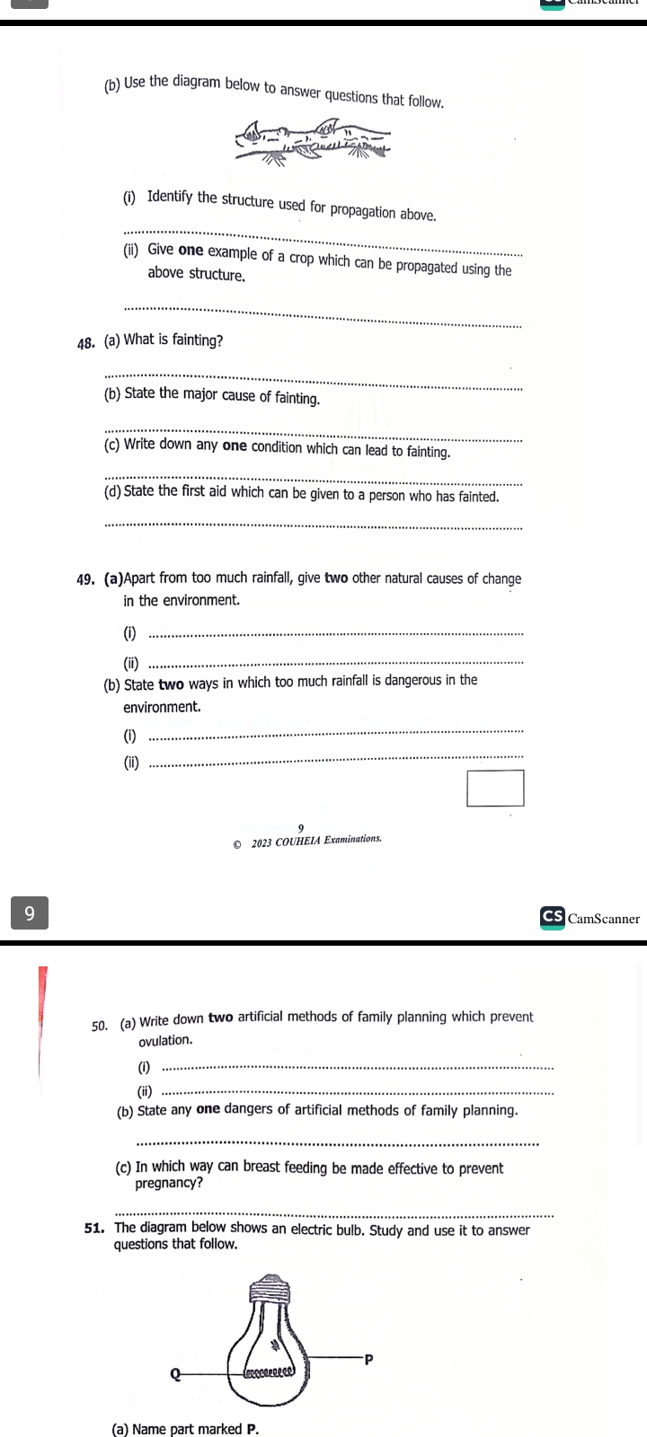

1. Identify the structure used for propagation above.

……………………………………………………………………………………………….

1. Give one example of a crop which can be propagated using the above structure.

……………………………………………………………………………………………….

1. a) What is fainting?

………………………………………………………………………….…………………….

b) State the major cause of fainting.

...………………………………………………… ……………….………………………....

c) Write down one condition which can lead to fainting. ………………………………………………………………….………………………….

d) State the first aid which can be given to a person who has fainted.

…………………………………………………………………….………………………….

1. a) Apart from too much rainfall, give two other natural causes of change in the environment.

i) ..………………………………………… ……………….………………………………....

ii) ………………………………………………………….………………………………….

b) State two ways in which too much rainfall is dangerous in the environment.

i) ..………………………………………… ……………….………………………………....

ii) ………………………………………………………….………………………………….

1. a) Write down two artificial methods of family planning which prevent ovulation.

i)…………………………………………… ……………….……………………………..

ii)………………………………………… ……………….……………………………….

b) State any one danger of artificial methods of family planning..

………………………………………………………………….……………………….....

c) In which way can breast feeding be made effective to prevent pregnancy?

……………………………………………………………….…………………………….

1. The diagram below shows an electric bulb. Study and use it to answer questions that follow.

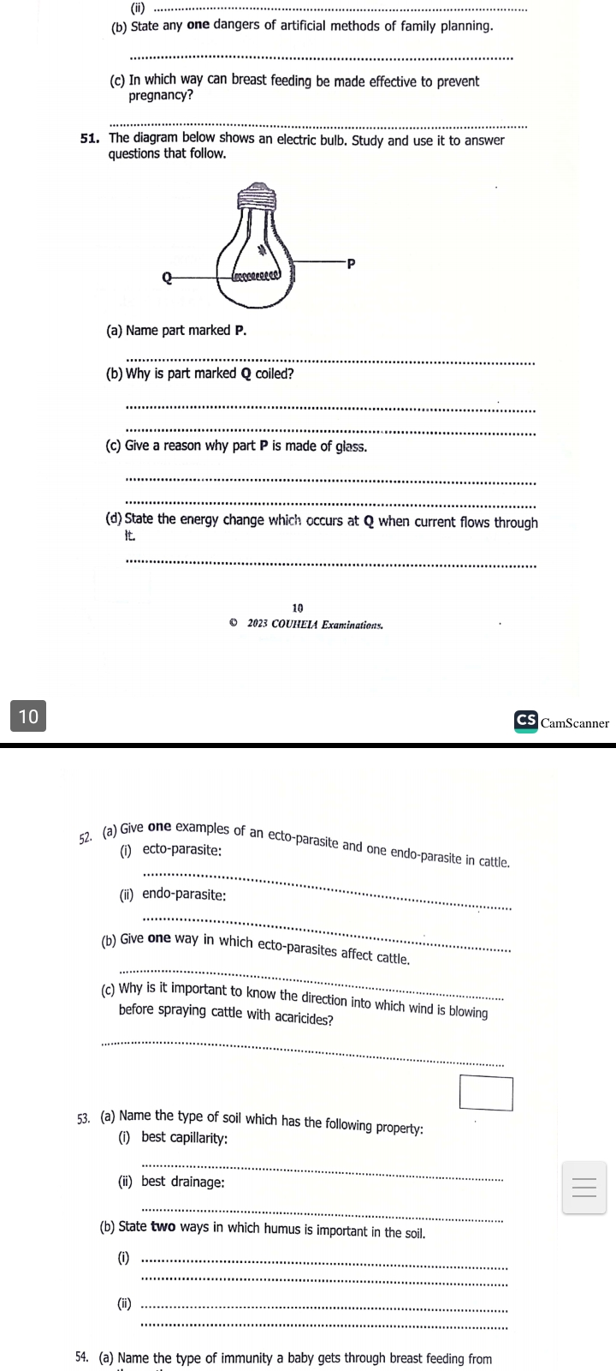

1. Name part marked P.

………………………………………………………………….………………………….....

b) Why is part marked Q coiled?

………………………………………………………………….………………………….....

c) Give a reason why part P is made of glass.

………………………………………………………………….………………………….....

d) State the energy change which occurs at Q when current flows through it.

…………………………….………………………………….………………………………

1. a) Give one examples of an ecto-parasite and one endo-parasite in cattle.

i) ecto-parasite

………………………………………………………………….………………………….....

ii) endo-parasite

………………………………………………………………….………………………….....

b) Give one way in which ecto-parasites affect cattle.

………………………………………………………………….………………………….....

c) Why is it important to know the direction into which wind is blowing before spraying cattle with acaricides?

………………………………………………………………….………………………….....

1. a) Name the type of soil which has the following property;
2. best capillarity…………………………………………….……………………………
3. best drainage;…..………………………………………………….………………………

b) State two ways in which humus is important in the soil.

1. ………..…………………………………………………………….………………………
2. …………………..………………………………………………….………………………
3. a) Name the type of immunity a baby gets through breast feeding from the mother.

…………………………………………………………………………………………………

b) Which mineral element does a mother lose through excessive breast feeding?

………….……………………………………………………………….……………………..

c) Apart from fluids, name one other food requirement for a breast feeding mother.

…………………………………………………………………………….………………….

d) Give a reason why breast feeding mothers should be given extra fluid to drink.

………………………………………………………………………………………………..

1. A man is provided with a single fixed and single movable pulley to use one of them to lift a load of 100N to the top of the building.
2. Which of the two pulleys should a man use to make the work easy?

………………………………………………………………………………………………

1. Give a reason for your answer in (a) above.

………………………………………………………………………………………………

1. Apart from friction, give one other force which makes work with pulleys difficult.

………………………………………………………………………………………………

1. How can friction be reduced in moving parts of machines?

………………………………………………………………………………………………**END**